KENYA SCOUTS ASSOCIATION
Membership Portal — Visual Quick Reference Guide
ksa.kenyascouts.com
Each screenshot below is numbered in step order, with a red box around the button or field to tap next. Follow the numbers in order.
1 | Create Your Account | New Member registration -> payment -> login
2 | Register a Unit | New unit (pay) or existing unit (no payment)
3 | Member Dashboard | Card, receipt, profile, password, progress

SECTION 1 Create Your Account
New Member Registration -> Payment -> Login

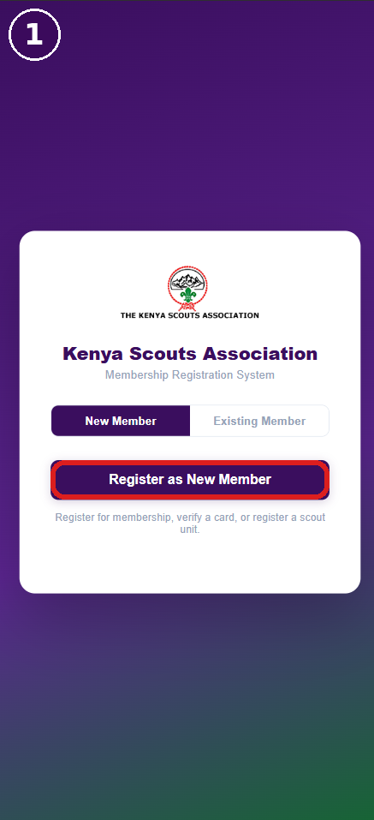  1. Open the portal  Go to ksa.kenyascouts.com. Keep 'New Member' selected, then tap 'Register as New Member' (boxed). | 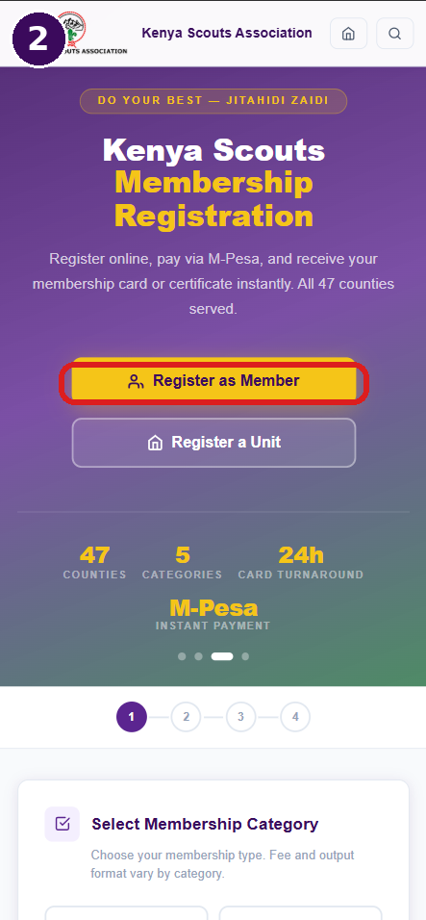  2. Register as Member  Tap the yellow 'Register as Member' button. ('Register a Unit' is covered in Section 2.) | 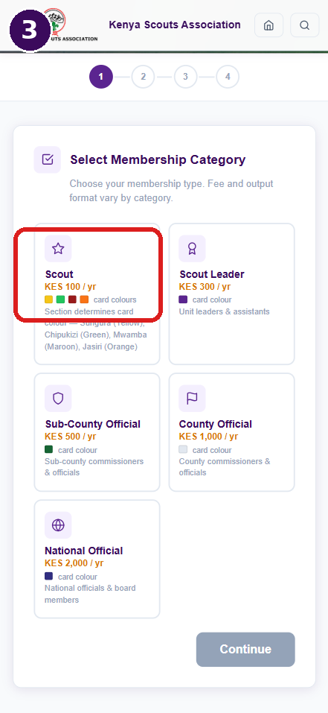  3. Pick a category  Choose Scout, Scout Leader, Sub-County/County/National Official. Fee & card colour depend on this.

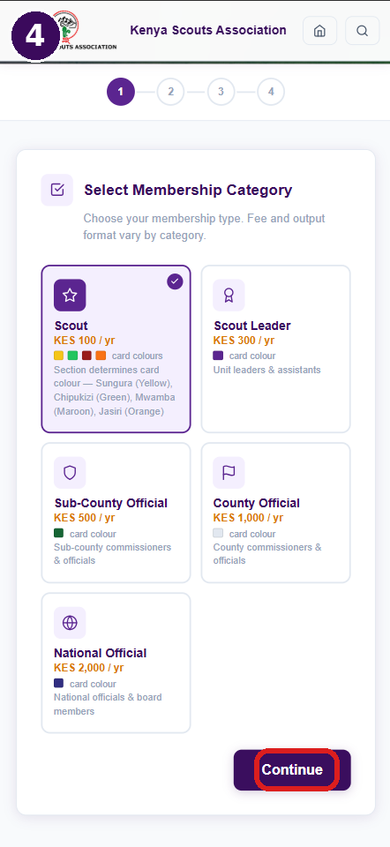  4. Confirm & continue  Selected category shows a purple border and check mark. Tap 'Continue' (boxed). | 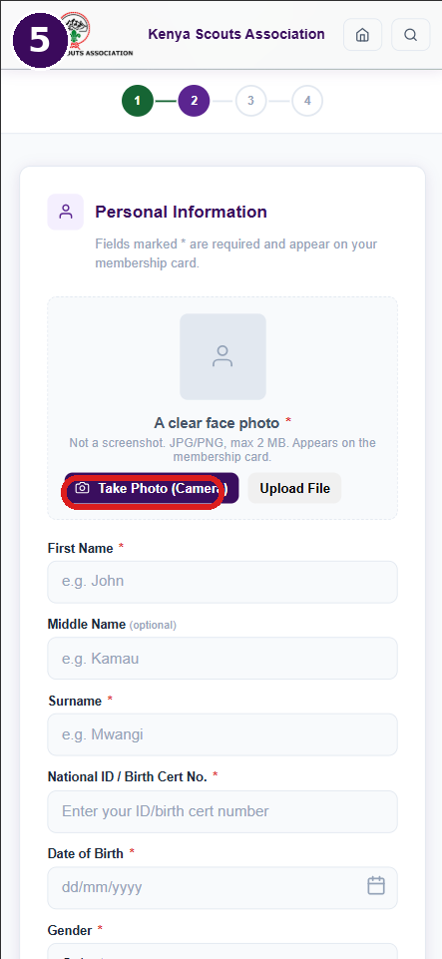  5. Add your photo  Take/upload a clear face photo (JPG/PNG, max 2MB, no screenshots), then fill in your personal details below. | 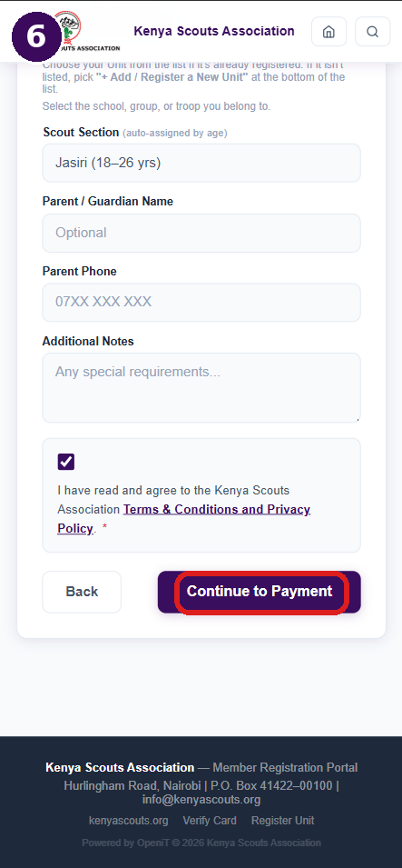  6. Continue to payment  Scroll down, tick the Terms & Conditions box, then tap 'Continue to Payment' (boxed).

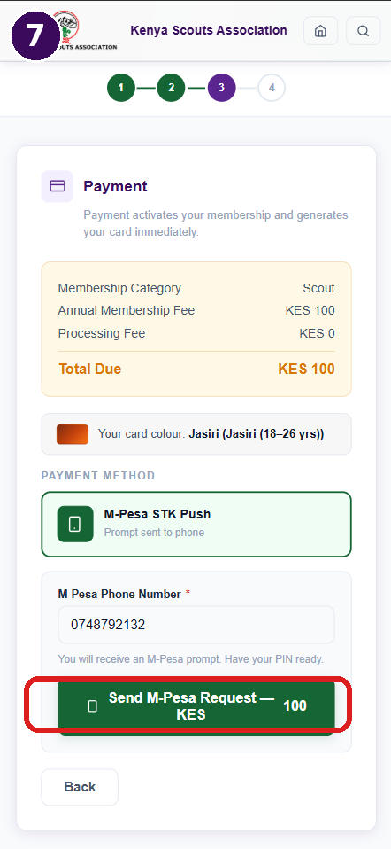  7. Pay via M-Pesa  Confirm the fee, enter your M-Pesa number, tap 'Send M-Pesa Request', then approve the STK prompt on your phone. | 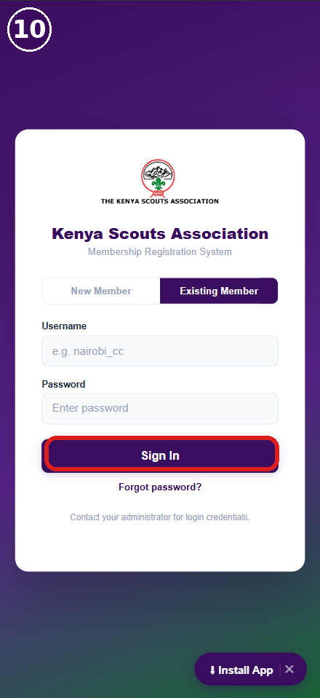  8. Log in  Check your email for your username & password, switch to 'Existing Member', then tap 'Sign In' (boxed). | 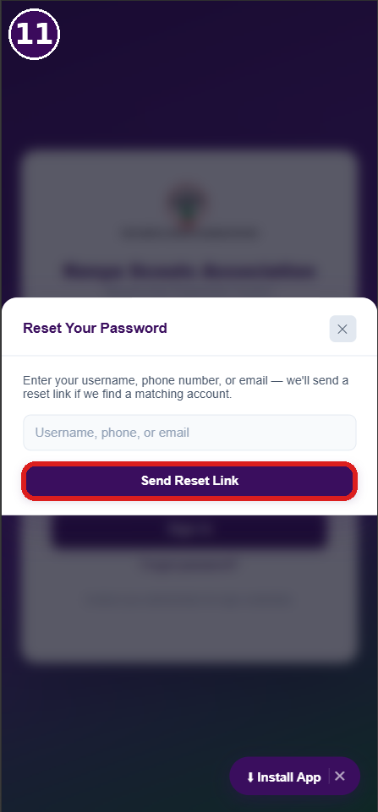  Forgot password?  Tap 'Forgot password?' on the login screen, enter your username/phone/email, then tap 'Send Reset Link' (boxed).

SECTION 2 Register a Unit
New Unit (pay now) or Existing Unit (already warranted)

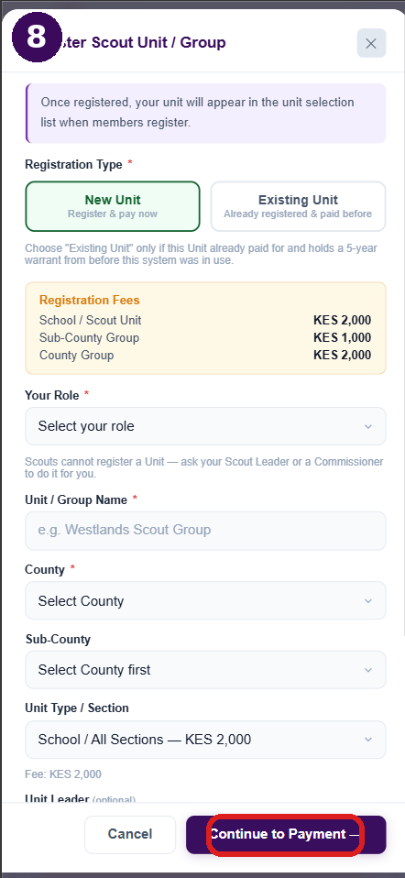  New Unit  Select 'New Unit', fill Role, Unit/Group Name, County, Sub-County & Type, then tap 'Continue to Payment' (boxed) and pay via M-Pesa. | 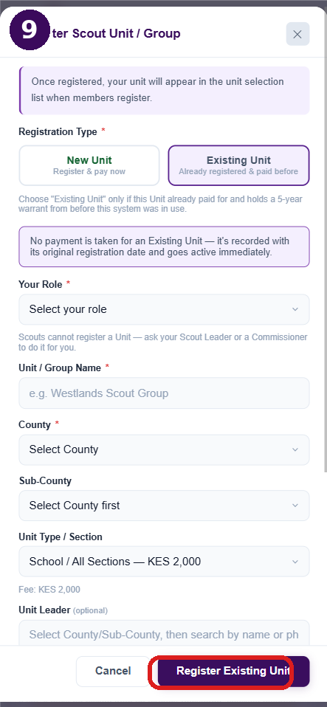  Existing Unit  Select 'Existing Unit' only if it already holds a 5-year warrant. No payment needed — tap 'Register Existing Unit' (boxed).

Fees (New Unit): School/Scout Unit — KES 2,000 | Sub-County Group — KES 1,000 | County Group — KES 2,000. Scouts cannot register a unit — ask your Scout Leader or a Commissioner. Once registered, the unit appears in the unit-selection list for members to pick.

SECTION 3 Member Dashboard
Card - Receipt - Profile - Password - Progress

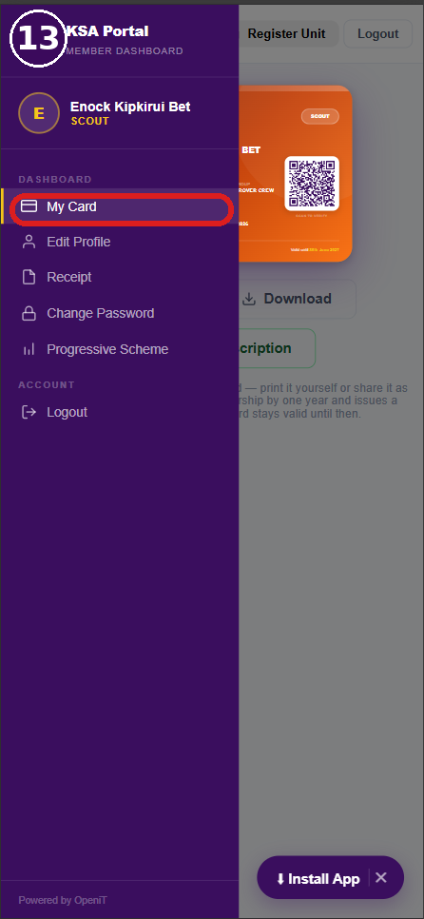  Open the menu  Tap the 3-bar menu icon top-left to open the sidebar. 'My Card' is boxed here — tap it to see your card. | 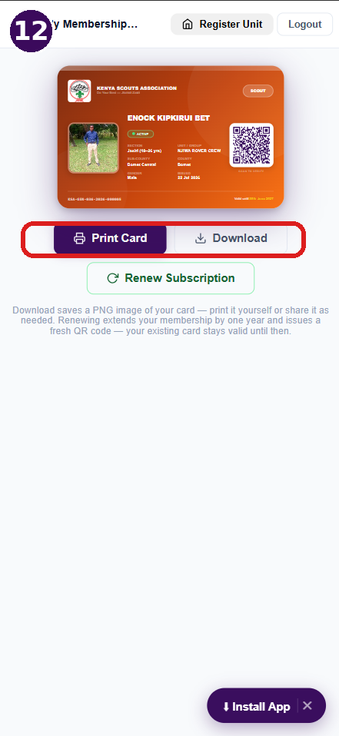  My Card  Your digital card with photo, QR code & status. Print or Download it here (boxed), or renew your subscription below. | 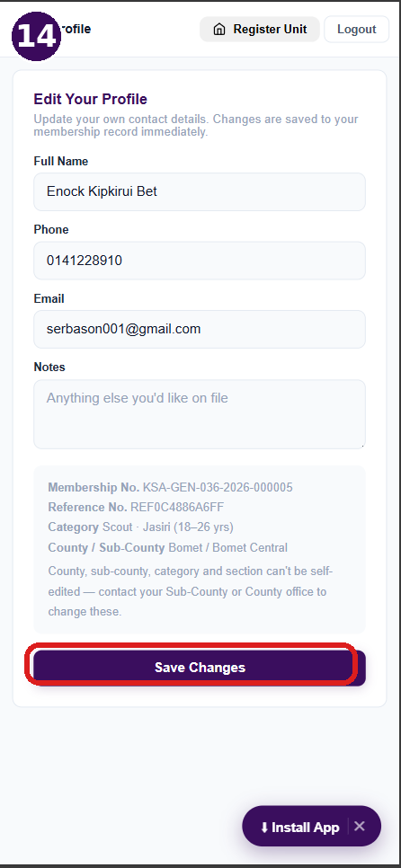  Edit Profile  Update Name, Phone, Email & Notes, then tap 'Save Changes' (boxed). Category/County are locked — contact your office to change.

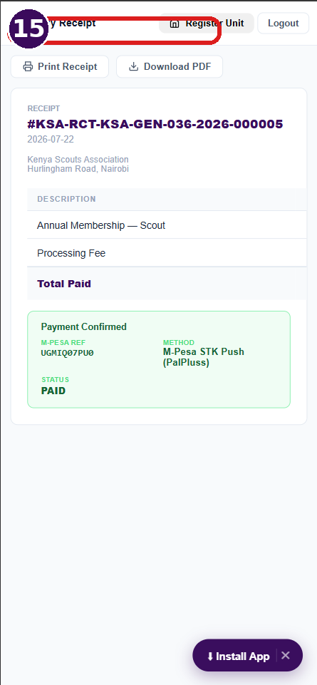  Receipt  View your payment reference, M-Pesa ref & status. Use 'Print Receipt' or 'Download PDF' (boxed) at the top. | 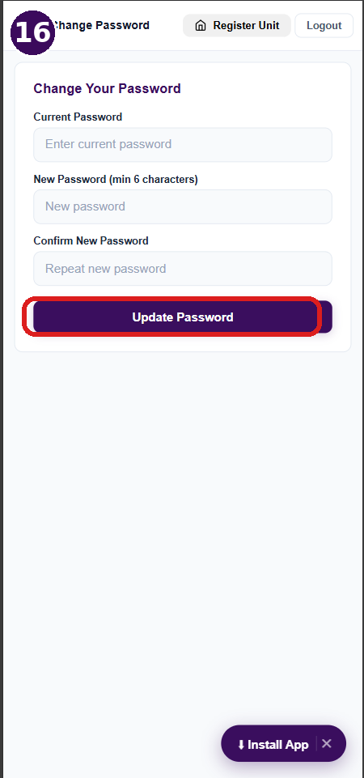  Change Password  Enter your current password, then a new one twice, and tap 'Update Password' (boxed). | 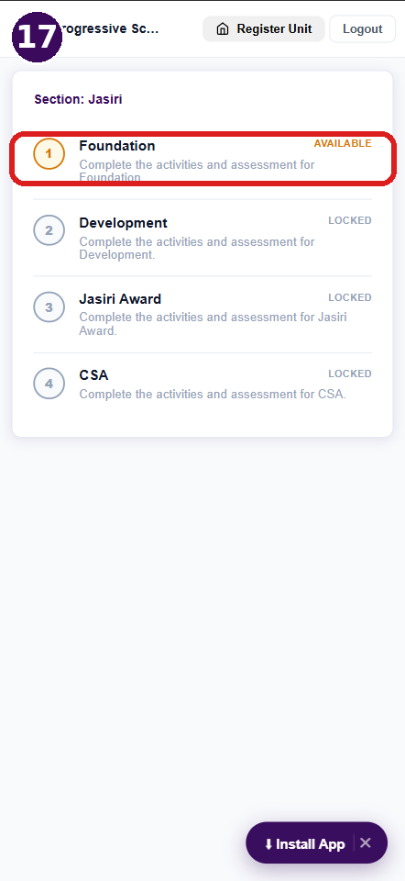  Progressive Scheme  Track your section's award stages — each one (boxed = available) unlocks after you complete the previous stage.

Scan to Begin
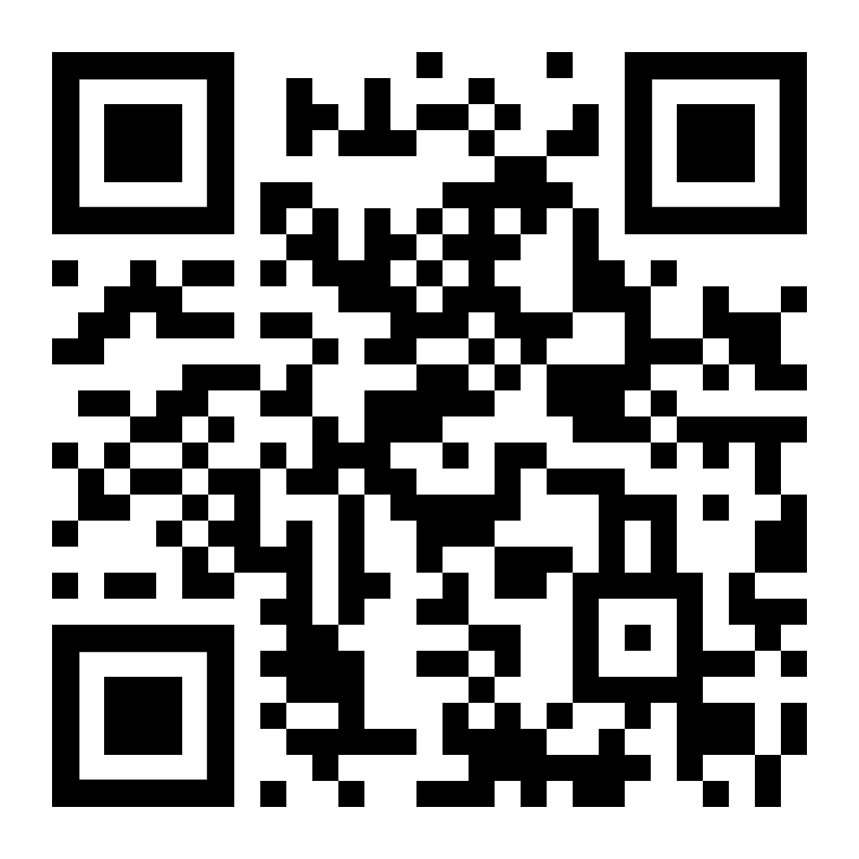
ksa.kenyascouts.com
Point your phone camera at the code to open the portal directly.

Kenya Scouts Association
Hurlingham Road, Nairobi | P.O. Box 41422–00100
reg@kenyascouts.com
+254 748 799 227 · +254 733 919 333
ksa.kenyascouts.com

